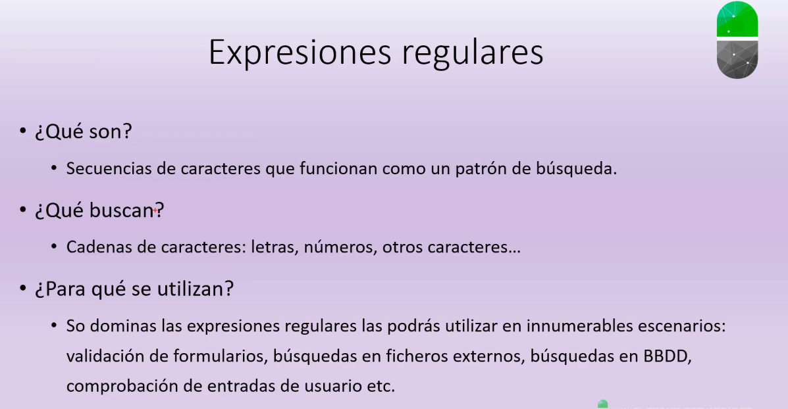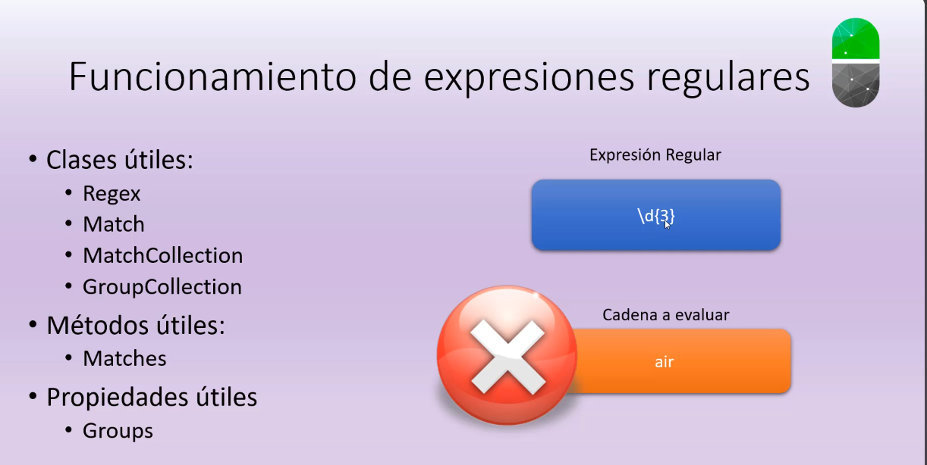

Links claves:

* <https://learn.microsoft.com/es-es/dotnet/standard/base-types/regular-expression-language-quick-reference>
* <https://learn.microsoft.com/es-es/dotnet/api/system.text.regularexpressions.regex?view=net-8.0>
* <https://www.txt2regex.com/>